ROOM RESERVATION REQUEST FORM
BOARDER MANAGEMENT & TECHNOLOGIES ASIA SUMMIT 2022
(IBMATA)
(Event Dates: 20-22 September 2022)

Kindly fill up details in RED (*) column and delete where necessary.
COMPLETE DETAILS IN FULL
*Title: | Choose an item.
*Family Name: |  | Passport No:
*Given Name: |  | Job Title:
*Arrival Date: |  | Flight Details Arrival:
*Departure date: |  | Flight Details Departure:
Email: |  | Reservation made on (date)
Company:

Room Type | Rates (Single) |  | Rates (Double)
Deluxe Plus Room  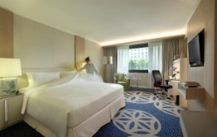 | S$215.00++ per room per night  - Daily breakfast for 1 person  - Free Wi-Fi connectivity for multiple devices | ☐ | S$230.00++ per room per night  - Daily breakfast for 2 persons  - Free Wi-Fi connectivity for multiple devices | ☐
Premier Club Room  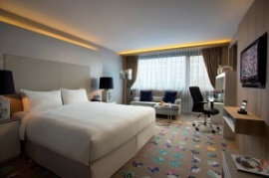 | S$265.00++ per room per night  (inclusive of club benefits)  - See list below | ☐ | S$285.00++ per room per night  (inclusive of club benefits)  - See list below | ☐
All the rates are in Singapore dollars and are subject to 10% service charge and prevailing goods & services tax, currently 7%. All bookings must be made directly with the hotel. The above special rates are available for participants for accommodation on pre, post and event dates.

BENEFITS OF PREMIER CLUB ROOMS
- Free minibar (replenishment will be done once daily)
- Complimentary: BREAKFAST in any of the 3 venues: Premier Lounge, Spices Café or Room Service; EVENING COCKTAILS (6pm to 8pm) including beer and house pouring wines. Guests are entitled to invite one guest for Evening Cocktails; LAUNDRY or pressing of two (2) pieces daily per room which is non-accumulative (excludes dry cleaning); FREE WIFI connectivity for multiple devices.
- Complimentary use of Premier Lounge meeting room for 2 hours per stay. Subsequent hours are chargeable

Options of Payment Method
*CREDIT CARD GUARANTEE
☐ Master |  | ☐ Visa |  | ☐ American Express
Card No: |  |  | Expiry Date:
Cardholder’s Name: | Enter your first name
*Please provide credit card details to guarantee your booking.

CANCELLATION POLICY
For guaranteed bookings, the Hotel reserves the right to charge the individual guest for the full duration of stay for any cancellation or release of rooms made two (2) days (48 hours) prior arrival date.

ROOM RESERVATIONS
Please send your completed form to our Reservations Department:
Email: reservations.chs@concorde.net / Direct tel: +65 67398303/ 04 / 08 / Hotel General Tel: +65 67338855
Please be advised that your reservations will only be deemed as confirmed when you have received this form back from our Reservations Department with the confirmation number given.

SALES CONTACT
Sulianto Tee (Senior Sales Manager): Email sulianto.tee@concorde.net / Direct Tel: +65 6739 8320 Mobile : +65 96512286

